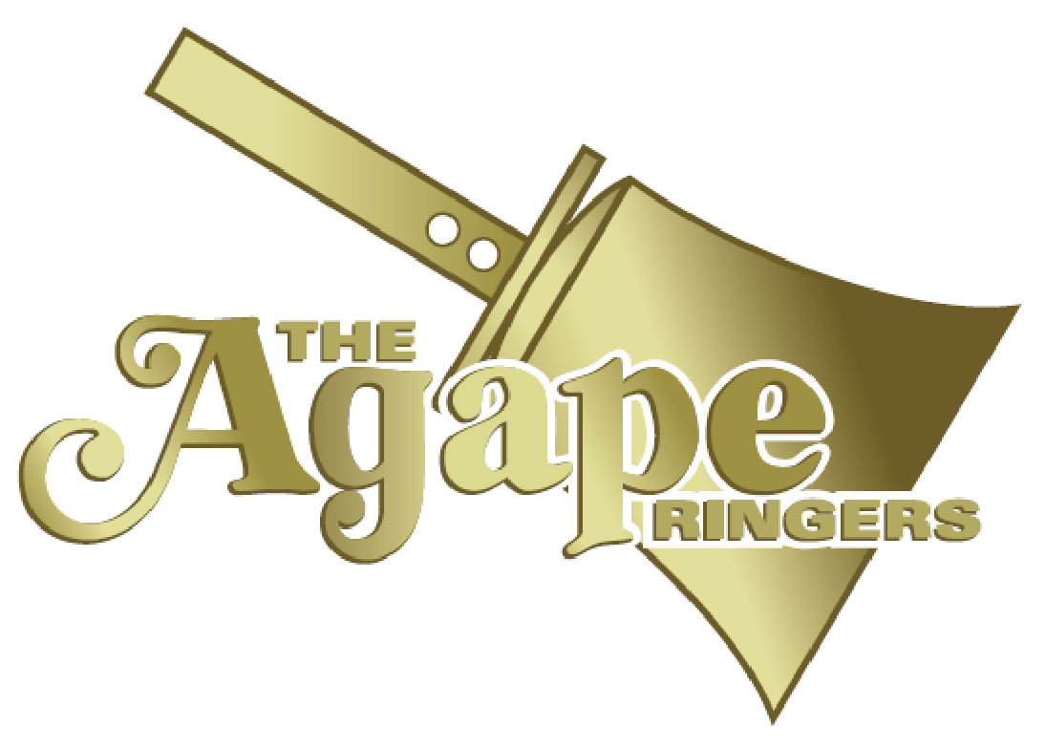

The Agape Ringers
SAMPLE SHORT ANNOUNCEMENT
Please use this in your internal communications such as worship bulletins, newsletters,
and e-mail communications.

Version One
Join us in the [location] on [day], [date] at [time] for a concert by The Agape Ringers, Chicago’s premier handbell ensemble. You can learn more about the ensemble at their website www.AgapeRingers.org, and on Facebook and YouTube by searching for “The Agape Ringers.”
The current program encompasses a wide variety of musical styles, from classical to boogie, with arrangements of well-known pieces such as Andrea Bocelli’s “Time to Say Goodbye;” “Flight of the Bumblebee,” arranged as “Bumble Boogie;” “For Good” from the Broadway hit Wicked; and many more compositions for handbells.

Version Two (SHORTER)
Join us in the [location] on [day], [date] at [time] for a concert by The Agape Ringers, Chicago’s premier handbell ensemble. You can learn more about the ensemble at their website www.AgapeRingers.org, and on Facebook and YouTube by searching for “The Agape Ringers.” The program encompasses a wide variety of musical styles from transcriptions of classical works to Broadway hits to original compositions. [Site to add ticket and contact information.]

Version Three (HOOK)
Join us in the [location] on [day], [date] at [time] for a concert by The Agape Ringers, Chicago’s premier handbell ensemble. The sixteen members of The Agape Ringers use over 200 bells and chimes to perform musical styles ranging from classical to jazz to familiar pop music. Founded in 1992, they have earned rave reviews from audiences across the United States, Canada, and England. [add ticket and contact information]
The Agape Ringers have performed as guest artists with jazz trumpeter Orbert Davis, the Rockford Symphony, the North Shore Choral Society, the Illinois Brass Band, the Elgin Choral Union, the Elmhurst Symphony, and the West Towns Chorus. You can learn more about them on the web at www.AgapeRingers.org, and on Facebook and YouTube by searching for “The Agape Ringers.” You can also stream The Agape Ringers on any major music streaming platform, including Spotify and Apple Music.

